Nicholas Robertson

Dennis Attawia

CST-105

March 19, 2017

**NFL Draft Application Storyboard**

Main Page

This is the screen that appears when the application is first opened. The **Enter Draft** button will take the user to the **Player Selection** screen, which will be the central location in which the draft takes place.

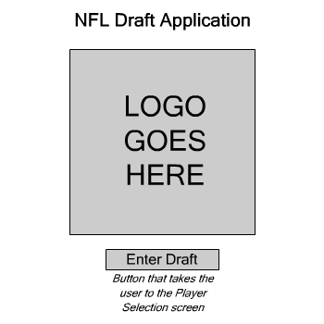

Player Selection

This is the main **Player Selection** screen. The user will be able to view all of the players who have entered the draft, selecting from a list of filters or by searching for the player’s name. The user will be able to draft or remove players from this screen.

The four buttons at the bottom of the screen are as follows:

* **Draft Player**: Adds the selected player to the list of drafted players.
* **Remove Player**: Removes the selected player, if already drafted, from the list of drafted players.
* **Player Card**: Opens a new screen with detailed information about the selected player.
* **End Draft**: Completes the draft and takes the user to the **Team Review** screen.

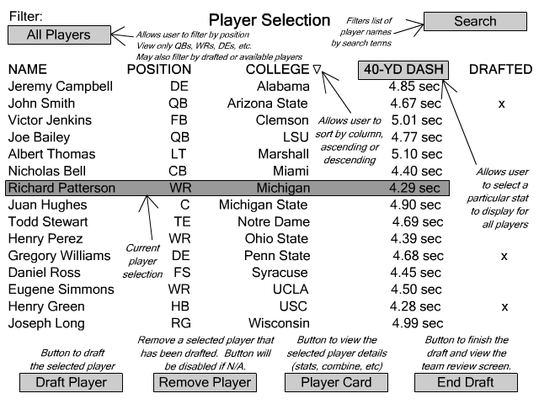

The list of players will be stored in an array of NFLPlayer objects. Each player will have a unique ID (index) used to retrieve and display their data. The class contains private fields for each possible statistic. Stats such as yards-per-attempt and quarterback rating have individual getter methods but cannot be set manually, as they are calculated based on the gross statistics (pass attempts, passing yards, passing touchdowns, etc.). All gross statistics have getter and setter methods. None of the fields in the class are set to public, only the methods.

Filter Player

This is the list of available filters that the user can select. The user can filter by the player’s position (quarterback, wide receiver, defensive end, etc.) or their availability (drafted or undrafted). The NFLPlayer class contains an IsDrafted boolean field which defaults to false but will change to true upon the player being drafted.

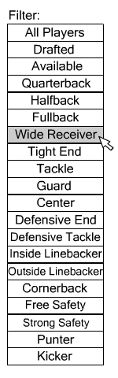

Search Player

The **Search Player** screen will be a pop-up that will allow the user to filter the list of players by entering either the entire name or a partial name. For example, selecting the **Last Name** button and entering a search of “Thom” would display players with last names such as “Thomas” or “Thompson”. The **Clear** button will clear the existing search filter and display all the players in the draft.

Because the NFLPlayer class contains separate string fields for FirstName and LastName, searching between the first or last names will be a simple task. The class also contains a getFullName method which will be used when the “Both” option is selected. The getFullName method concatenates the FirstName and LastName together into a new string.

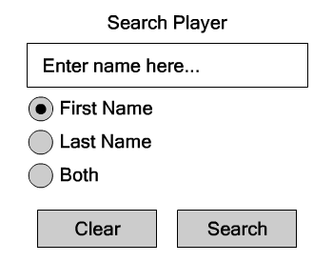

If no results are found, a dialog box will display.

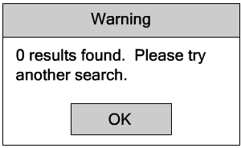

Player Card

The **Player Card** screen is accessed from the **Player Selection** screen by selecting a player and clicking the **Player Card** button. This page will display a detailed description of the selected player, including their height, weight, combine results, college statistics, and the college they attended.

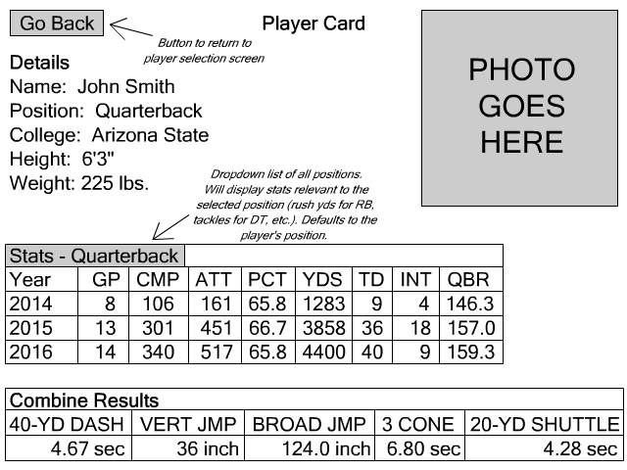

The NFLPlayer() class allows for flexibility in that a player on offense can still have defensive stats, such as a wide receiver playing in prevent and intercepting a Hail Mary pass attempt. All stat categories will be selectable for each player.

Team Review

The **Team Review** screen provides an overview of the drafted players and when they were taken. The user is able to view the selected player’s card or exit the program.

